Why $9 for Shipping?

A donation of $9 per shoebox gift is critical for Operation Christmas Child. It provides for:

Collection
After shoebox gifts are dropped off at nearly 5,000 locations around the United States each year in November, trucks transport the precious cargo to eight different processing centers.

Processing
Eight processing center warehouses around the country are secured so that thousands of volunteers can inspect the shoebox gifts and prepare them for international shipment.

Shipping to Over 100 Countries
Ships, trucks, and airplanes transport millions of shoeboxes to the countries where they will be distributed. Once there, local churches use many modes of transportation to get them to children in need as a tangible expression of God's love.

Gospel Materials
Your $9 donation to Operation Christmas Child, a project of Samaritan's Purse, helps us train and equip local churches to use our Ministry Partner Guide. This resource shows churches how to share the Good News of the Lord Jesus Christ in a child-friendly way.
Your donation also provides The Greatest Gift Gospel Booklets, which are written in the children's language and distributed along with shoebox gifts.

Gospel Materials
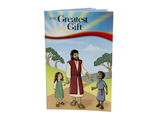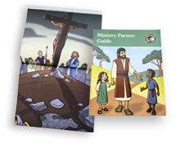

The Greatest Gift Gospel Booklet The Ministry Partner Guide
This booklet invites children to receive God’s Greatest Gift, This resource equips local churches with information
His Son, Jesus Christ. It is used in more than 80 languages. on how to organize a distribution, share the Gospel, and invite boys and girls to participate in follow-up discipleship

